Title

# Background

## Lesser Prairie Chicken

The Lesser prairie-chicken (*Tympanus pallidicinctus*) is a species of grouse native to regions of Colorado, Kansas, Oklahoma, Texas, and New Mexico. Throughout their range, Lesser prairie-chicken (LPC) require a mixture of sagebrush, native grass prairie, and shrublands. Much of this habitat has been lost as the result of conversion to agricultural land, and the distribution of LPC is now only 10% of its historical range. LPC habitat can also be degraded by energy development, due to the species’ avoidance of tall structures – a behavior adapted to avoid aerial predators[1].

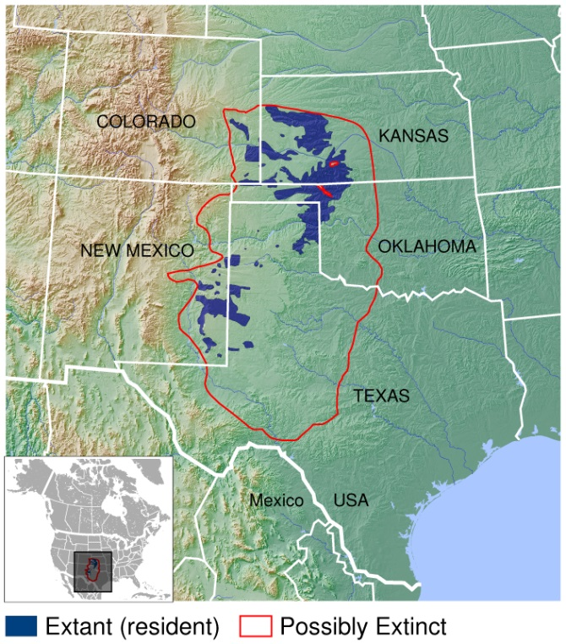In an effort to protect LPC, and prevent its listing as an endangered species, the Western Association of Fish and Wildlife Agencies developed a range wide conservation plan (RWP) in 2013. The RWP provides voluntary impact minimization, and mitigation strategies for private landowners and companies conducting activities that would degrade LPC habitat. Lesser prairie chicken was nevertheless listed as a threatened species under the Endangered Species Act (ESA) on March 27, 2014[2], at which point enrollment in the RWP was used by corporate developers to fulfill their obligation to offset ‘take’ under the ESA. A court ruling on September 1st, 2015 overturned the listing decision, and the LPC was removed from the endangered species list in April 2016. The RWP remains, but mitigation and impact minimization programs have reverted to purely voluntary efforts. The purpose of this analysis was to quantify the extent of energy development and habitat loss occurring since delisting, using a combination of publicly available data and remote sensing.

**Lesser prairie-chicken range**

Credit: IUCN Red List spatial data and GLOBE https://commons.wikimedia.org/w/index.php?curid=41506424

## Remote Sensing

Remote sensing describes the use of earth surface reflectance data, often collected by sensors on satellites, to document and measure patterns of land cover and land use. A recent proliferation of available satellite data has increased the use of remote sensing in conservation work. Many satellite systems collect new images across the globe on a bi-weekly basis, presenting a significant advance in the ability to quickly detect and quantify habitat loss. Satellite sensors also measure reflectance values beyond the visible spectrum, including infrared and ultraviolet light, providing a greater ability to distinguish among land cover types and features than photographs.

In this analysis, we used Google Earth Engine - a platform providing access to terabytes of real time satellite data, and the cloud computing capabilities to analyze them – to create an automated process to detect wind turbines, oil and gas wells, and habitat loss throughout the LPC’s range. The basic overview of the process shown in Figure 1 is:

1. Acquire ‘before’ and ‘after’ satellite data
2. Calculate changes in reflectance values
3. Select pixels exceeding reflectance change thresholds
4. Distinguish man-made vs. natural changes

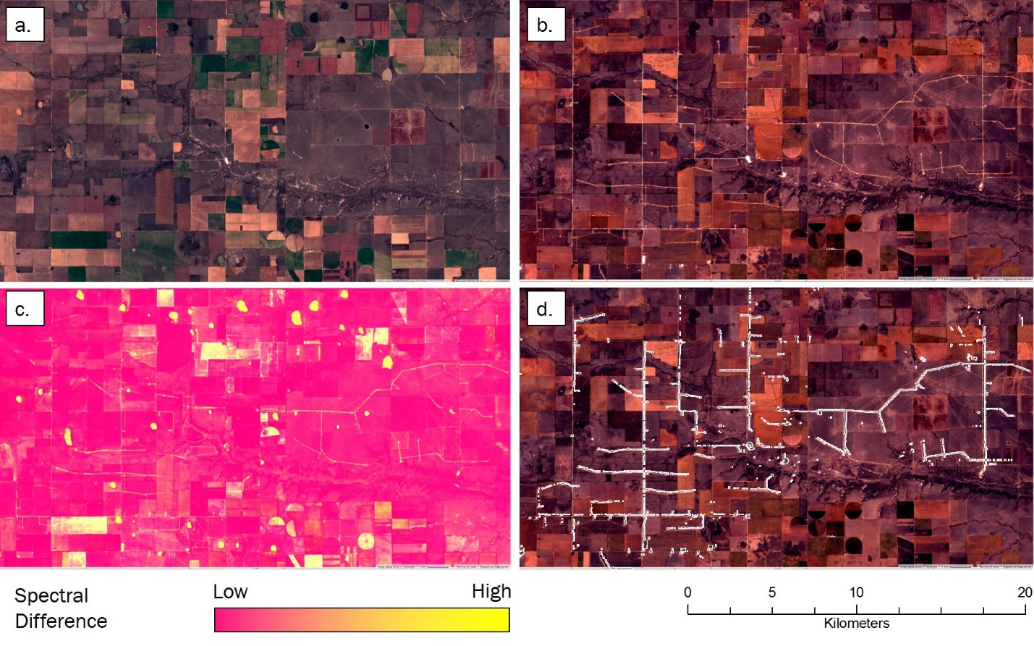

**Figure 2** Images at a wind farm constructed after September 1st, 2015 outlining the process of automated land cover change detection. First, images from before (a) and after (b) the date of interest are collected and processed, displayed here in the visible RGB spectrum. A suite of metrics measuring changes in pixel values across multiple parts of the spectrum are calculated and combined into an image representing the likelihood of land cover change (c). Pixels with change values exceeding pre-determined thresholds are selected, indicating areas of human disturbance (e.g. roads and turbine pads) occurring between before and after images (d). This process is applied across an area of interest to automatically detect human disturbances.

# Findings

## Wind Energy Development

Using our automated change detection procedure, we identified 5 wind farms with a total of 713 turbines constructed after September 1st, 2015 within LPC range. The LPC range wide plan uses a buffer of 667m around turbines to determine the area for which mitigation is needed. Under the RWP, construction of these 713 turbines would create 129,739 acres of potential mitigation area. From a biological perspective, LPC avoid tall structures up to 1 mile away, and this area surrounding wind turbines is considered biologically disturbed, or degraded habitat[3]. When a 1 mile buffer is considered, these 713 turbines create 257,577 acres of habitat disturbance for LPC.

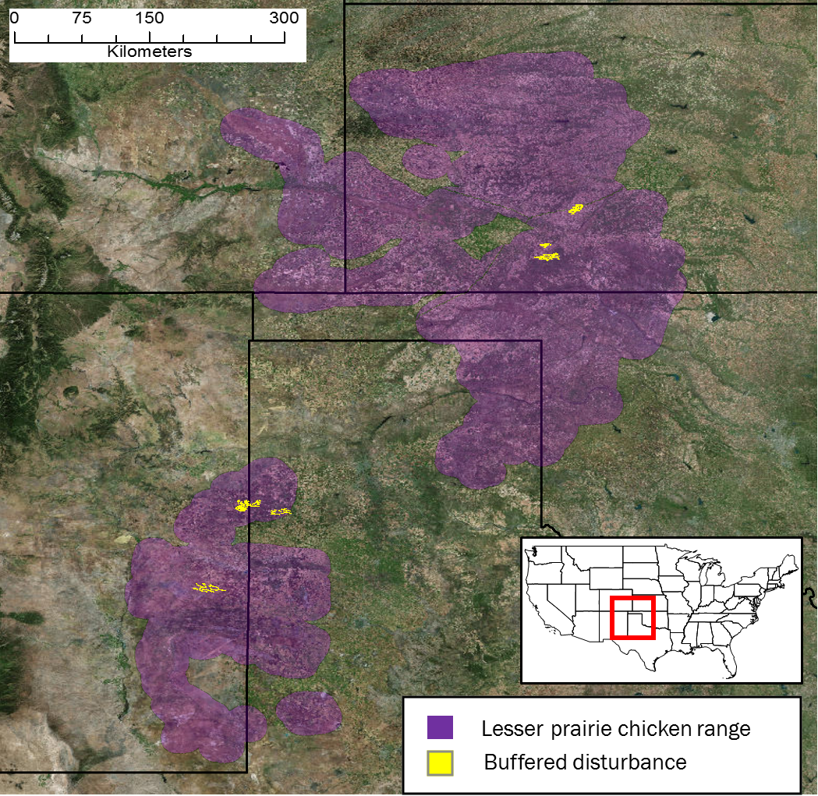

**Figure 3** Locations of wind farms within Lesser prairie-chicken range constructed between September 1st, 2015 and April 1st, 2017 identified by automated land cover change detection.

## Oil and Gas

Oil and gas drilling permits and production records are maintained by state oil and gas commissions, including project start dates and well locations. In theory, these records can be used to measure the number and location of disturbances within LPC habitat due to oil and gas drilling. We obtained all records (378) of new wells reported between September 1st 2015 located within LPC range, and verified the construction of a new well using before and after satellite imagery where available. Satellite images revealed new wells within 500m of reported locations for only 178 records (57%) of those we inspected.

|  |  |  |  |  |
| --- | --- | --- | --- | --- |
| **STATE** | **Wells Reported** | **Wells Inspected** | **New Wells Detected** | **Detection Rate** |
| CO | 1 | 1 | 1 | 100% |
| NM | 63 | 25 | 23 | 92.0% |
| TX | 132 | 105 | 49 | 46.7% |
| KS | 163 | 163 | 46 | 28.2% |
| OK | 19 | 16 | 3 | 18.7% |
| **TOTAL** | **378** | **310** | **178** | **57.4%** |

These discrepancies could be caused by errors in recording dates and/or coordinates, unreported changes in project timelines, or in many cases, vague constructions dates recorded by the states. For instance, New Mexico reports a ‘Spud date,’ the date on which ground was broken when drilling a new well. Kansas provides a ‘Year Start’ with well records, which leaves the actual date at which a new well is constructed ambiguous. We confirmed new wells at 92% of reported locations that were checked in New Mexico, but only 28% of those in Kansas.

Applying our change detection algorithm across LPC range identified 179 new well pads that appeared in LPC habitat since delisting, which did not correspond to any coordinates provided by the states (> 500m from any reported location). The RWP uses a buffer of 200 meters around oil and gas wells to determine the area for which mitigation is needed. The 178 reported wells we identified create 3,150 acres of potential mitigation area, after discounting the areas around wells built in already degraded habitat. The 179 additional wells we identified that were not associated with oil and gas commission records, created an additional 5,800 acres of potential mitigation area.

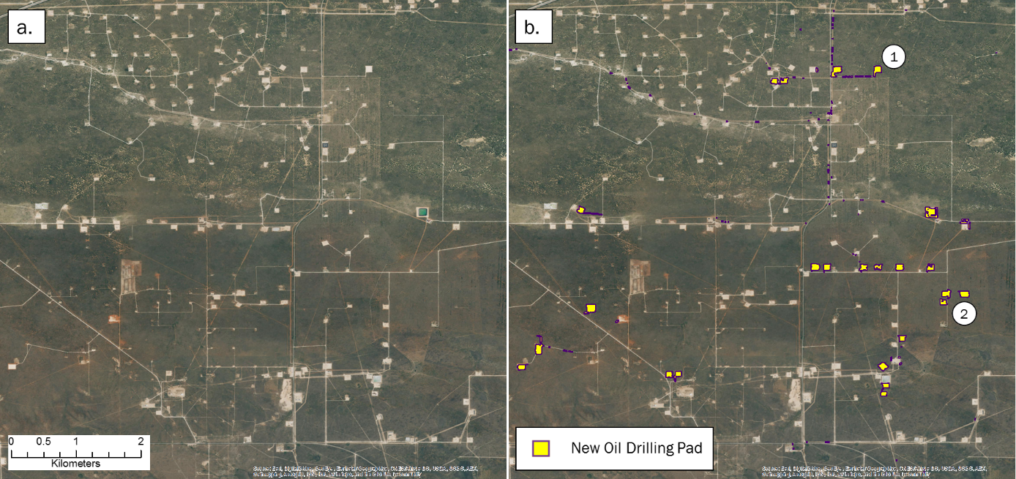

Figure 4 Example of oil well pads constructed between September 1st, 2015 and April 1st, 2017 identified by automated land cover change detection. Images in (a) and (b) are the most recent aerial photographs available on Google Earth from October 4th, 2016. Some pads constructed within the study period are already visible (1), while others were constructed more recently, and only detectable by more frequently collected remote sensing data (2).

## Habitat Loss

In addition to tracking energy development, we wanted to estimate the overall loss of LPC habitat across the species’ range since delisting. The majority of habitat loss is from conversion of native grass prairie and shrubland to agriculture. Using a measure of vegetation intensity, we identified ### acres that had been converted from LPC habitat in the growing season (April – October) of 2015 to agricultural land in the growing season of 2016.

In total, we estimate between 250,985 acres of LPC habitat was disturbed or lost since the species was delisted. In our selection of thresholds across all analyses, we applied a conservative approach, meaning these estimates likely represent the minimum number of disturbances and amount of habitat loss occurring during that time. By comparison, a study of agricultural conversion between 2008 and 2011 estimated ### acres

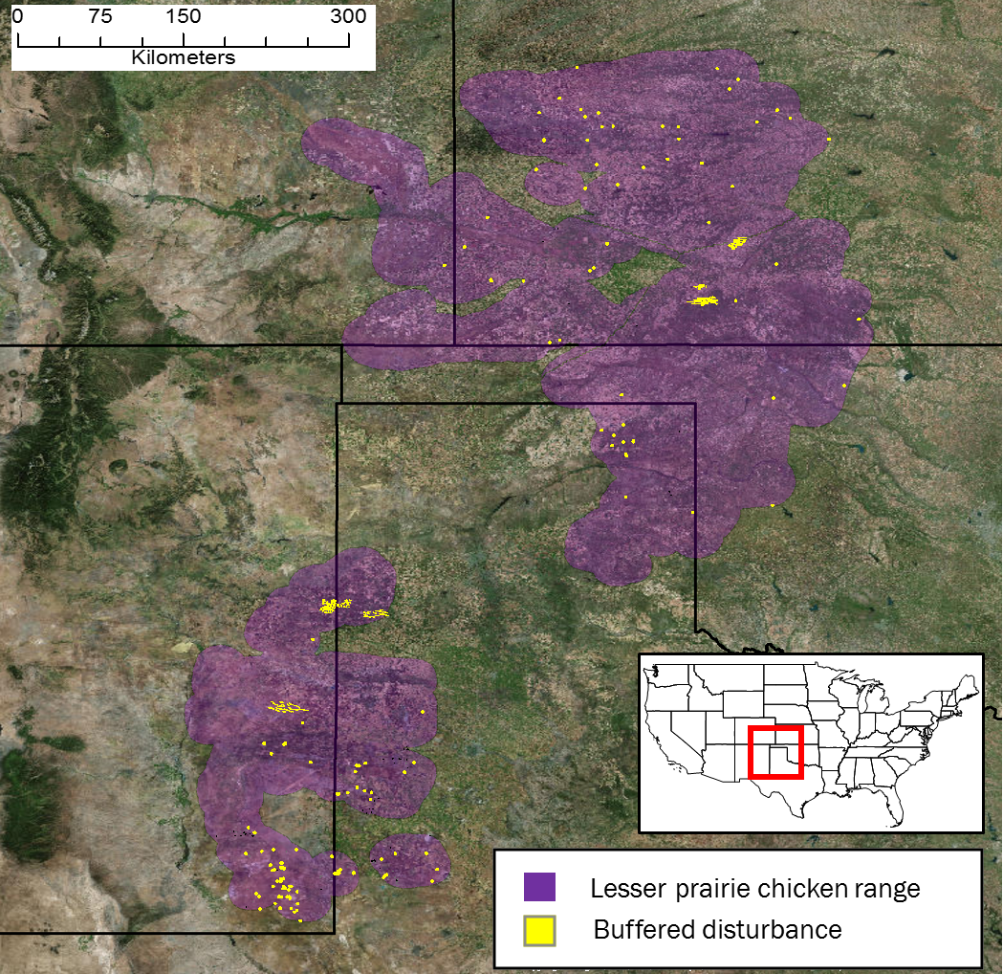

# Methods

## Satellite data

We used pre-processed Sentinel-2 satellite imagery, available on Google Earth Engine, to conduct change detection analyses. Sentinel-2 is a remote sensing satellite system deployed and maintained by the European Union, providing global coverage of 10m resolution imagery every 12 days. Sentinel-2 images contain 12 bands recording reflectance values in the visible, near infrared, short-wave infrared, and near ultraviolet spectra. To avoid the potential for seasonal phenology to confound true land cover change, we first selected Sentinel-2 scenes across LPC range acquired outside of the growing season (November to March). Scenes collected in 2015/16 were used as ‘before’ imagery and those in 2016/17 as ‘after’. We removed cloudy pixels from each image using a filter on the QA band, and created a single image composite by selecting the median value of each pixel stack.

## Change Detection Algorithm

Our automated change detection algorithm extended methodology used by the U.S Geological Survey to produce the National Land Cover Dataset (NLCD) land cover change data[4]. We calculated four spectral change metrics between before and after imagery. The Change Vector (CV) measures the total change in reflectance values between two images across the visible and infrared spectrum, and Relative CV Maximum (RCVMAX) measure the total of changes in each band scaled to their global maxima. Differences in Normalized Difference Vegetation Index (dNDVI) uses ratios between near infrared and red reflectance to indicate changes in the concentration of vegetation. We additionally calculated differences in a Ratio Normalized Difference Soil Index (dRNDSI)[5], which uses ratios between short-wave infrared and green reflectance to indicate changes in the concentration of bare ground. Pixel values for each change metric were converted to z-scores representing the likelihood of land cover change relative to global means for normalized indices (RNDSI & NDVI), and global minimums for scaled indices (CV and RCVMAX). The output was a four-band image consisting of the standardized z-scores for each change metric at each pixel, covering the entire LPC range. All calculations and transformations were performed in Google Earth Engine.

## Change Validation

Due to the distinct spatial pattern of wind farms (Figure 1d), we identified new farms by examining the change metric output visualized to highlight losses in vegetation and increases in bare ground. We then visually inspected the most recent available Sentinel-2 imagery at new wind farm locations to identify and mark individual turbines. Oil and gas well pads are small and less distinct. Therefore, we defined change metric thresholds that identified replacement of natural land cover with well pads. We selected a set of 100 validation plots from the change metric image in areas with high change likelihoods that did (true positive) and did not (false positive) correspond to the addition of well pads. We extracted the change metric z-scores within these validation plots, and performed linear discriminant analysis (LDA) to estimate the coefficients for a linear transformation maximizing differentiation between true and false positive validation data. We used a receiver operating characteristic (ROC) curve and selected the LDA score maximizing the second derivative (i.e., rate of change in curve slope) of the relationship between false positive and detection rate (Figure 4a), as a threshold for automatically identifying new well pads. We then converted areas meeting or exceeding this threshold to change polygons. LDA and ROC analyses were conducted in *R* using the *pscl* and *pROC* packages.

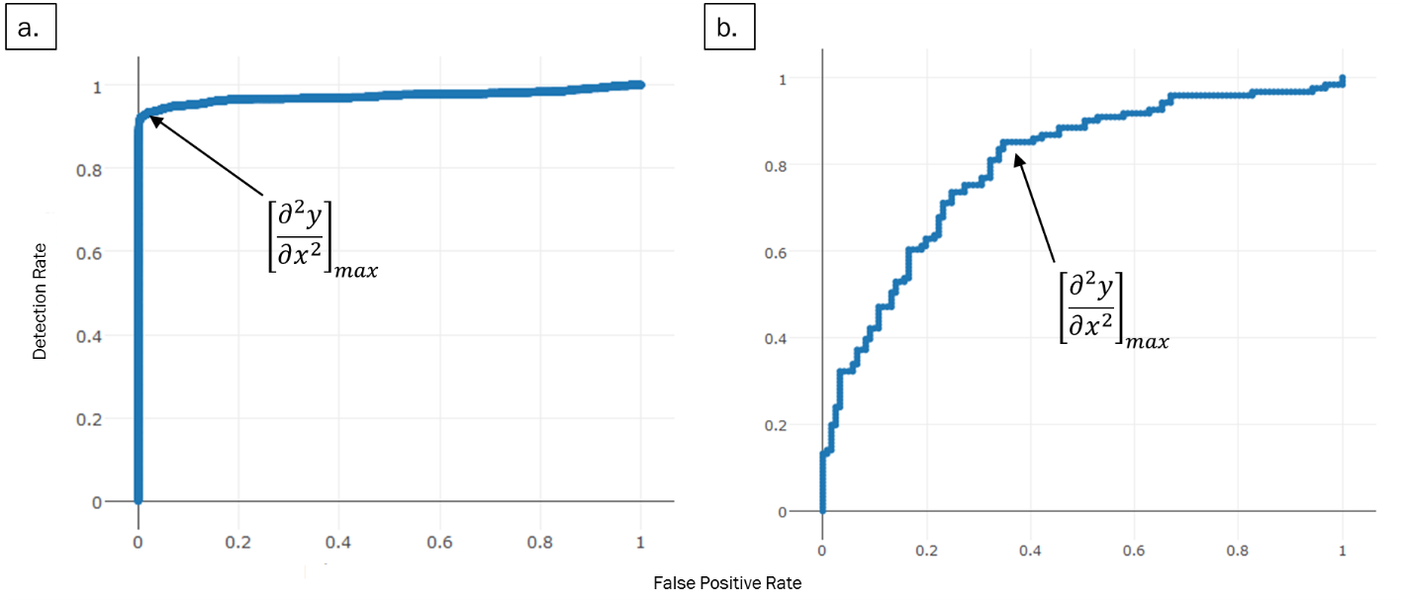

**Figure 5** Receiver operating characteristic (ROC) curves plotting linear discriminant analysis scores for change metrics (a) and shape metrics (b) to identify new oil and gas well pads. The values at which the rate of increase in detection rate relative to false positive rate decreases most rapidly (indicated by arrows) were selected as threshold values.

We then needed to discriminate between natural land cover changes that matched well pad spectral characteristics, and true human disturbances. We calculated a suite of shape metrics for each land cover change polygon, including convexivity, circularity, elongation, and compactness, that had the potential to delineate more regular, compact shapes formed by human activity from irregular shapes associated with natural land cover change[6]. We then manually classified a validation set of 400 polygons, and as with reflectance thresholds, used LDA and ROC curves to identify values discriminating between true and false positives (Figure 4b). We then examined the most recent Sentinel-2 imagery at each polygon meeting spectral and shape criteria to confirm the presence of a well pad constructed after September 1st, 2015, and deleting all other polygons. For each choice of threshold, the true positive detection rate was less than one, and therefore this approach eliminated a small set of true human disturbances. Thus, the results reported represent a lower bound for the minimum number of new pads.

## Mitigation Area Calculation

We further restricted the set of oil and well pads to those occurring within areas identified as shrub/scrub, or grassland by the NLCD 2011 classifications. This eliminated disturbances occurring within already degraded habitat (i.e. agriculture) from further consideration. The RWP requires a buffer distance of 200 m around oil and gas wells, and 667 m around wind turbines to determine disturbed acreage that must be offset by habitat mitigation. To estimate lost potential mitigation opportunities, we buffered the new well pad polygons and turbine locations by their respective distances. We then eliminated buffered areas within which disturbances were already present (Figure 5a), as these could have potentially already been mitigated, or constitute degraded habitat, and thus be subject to discounted mitigation acreage[7]. Estimated potential mitigation acreage was calculated as the total acreage of all remaining buffered areas.

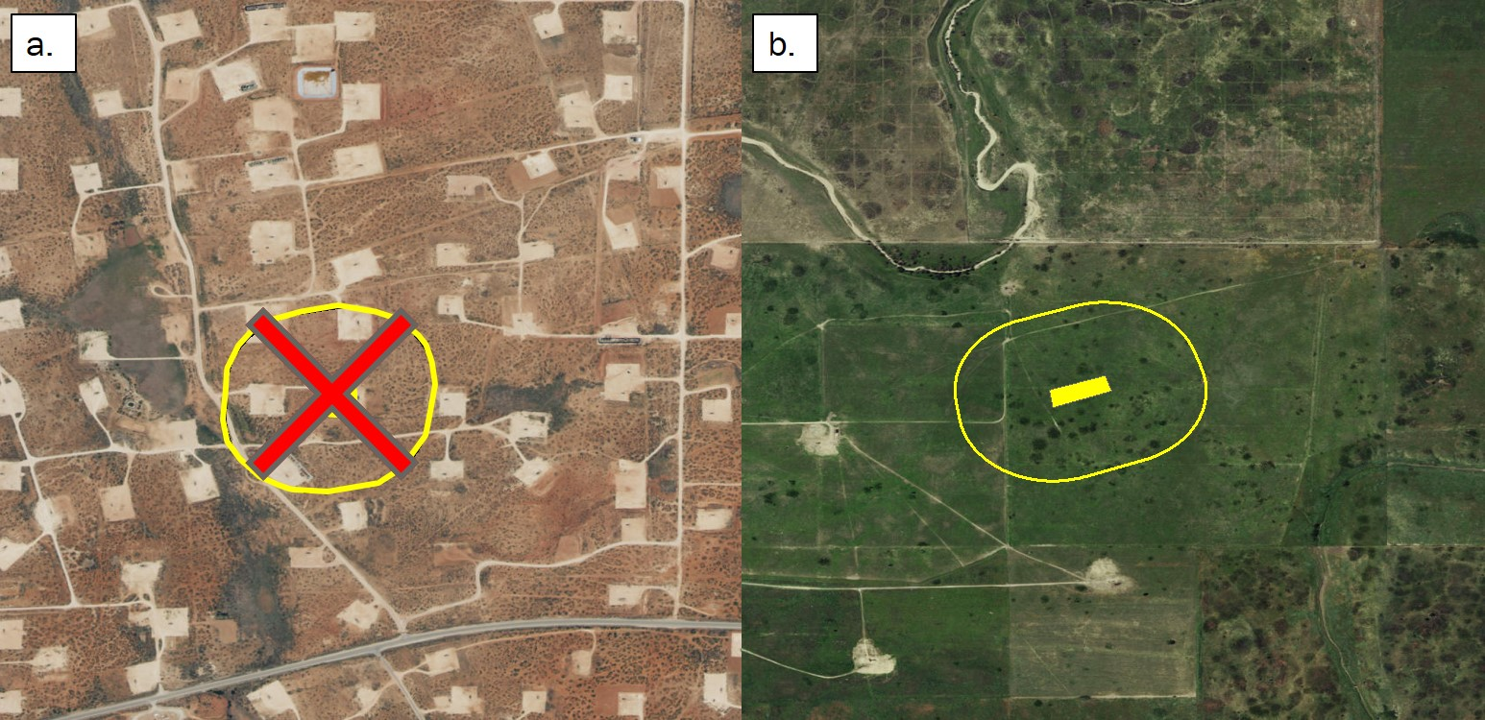

**Figure 6** Buffered areas surrounding oil and gas wells encompassing already highly disturbed areas (a) were not included in our calculation of total potential mitigation acreage. Only areas containing primarily intact LPC habitat (b) were included.

1. Hagen, C.A. et al. (2011) Impacts of anthropogenic features on habitat use by Lesser prairie-chickens. In: *Ecology, conservation, and management of grouse. Studies in Avian Biology*, University of California Press, Berkeley, CA.
2. U.S. Fish and Wildlife Service, Determination of threatened status for the Lesser prairie chicken; Final Rule April 10, 2014
3. Determination of Threatened status for the Lesser prairie-chicken. U.S. Fish and Wildlife Service, April 10, 2014.
4. Jin, S. et al. (2013) A comprehensive change detection method for updating the National Land Cover Database to circa 2011. *Remote Sensing of Environment*, 132: 159-175.
5. Deng, Y. et al. (2015) RNDSI: A ratio normalized difference soil index for remote sensing of urban/suburban environments. *International Journal of Applied Earth Observation and Geoinformation*, 39: 40-48.
6. Jiao, L. & Liu, Y. (2012) Analyzing the shape characteristics of land use classes in remote sensing imagery. *ISPRS Annals of the Photogrammetry, Remote Sensing and PSatial Information Sciences, (I-7)*:135-140
7. Van Pelt, W.E. et al. (2013) The Lesser prairie-chicken range-wide conservation plan. *Western Association of Fish and Wildlife Agencies*, Cheyenne, WY.